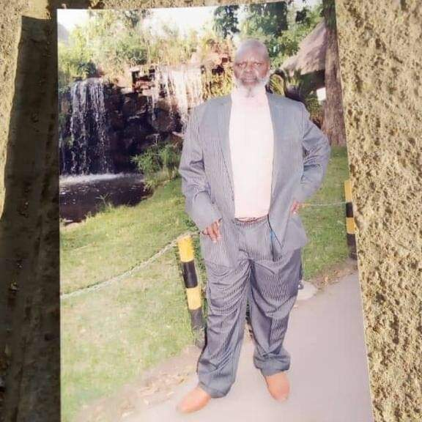

PRELIMINARY REGISTRATION FORM

Registration Code (from your basic coach(es):

MC 1006

\*Name\*

Africa Chikomana

\*Name of your basic coach (es) & their numbers\*

Anthonia Lola Dickson

+27 78 789 5791

\*Discipline\*

Artisan

\*How did you hear about the training\*

I heard about the training through an online publication inserted by my coach Anthonia Lola Dickson.

\*How much did you pay\*

N3000

\*Bank\*

First City Monument Bank

Date of payment\*

30.03.21

\*Do you have a Kdp account:\* yes or no

Yes

\*If no, why\* :

\*Are you published on Kdp\* : yes or no

No

\*If no, why\* :

Still aspiring to get published.

\*Grade expected\*:

Distinction.

\*Were you told you'd make money graduating\*:

Yes.

(Give details)

Through publishing my own books, and assisting others to publish theirs as well.

\*Do you have a manuscript\*:

No.

Are you an author or a consultant:

No.

Why are you here:

To acquire the best knowledge and skill in professional writing.

Expectations from the Masters Class

To become the master of Ebook publishing, and instruct new aspiring but uninformed writers.